1. **Write a Java program, to take a HDFS Path as input and display all the files and sub-directories in** **that HDFS path.**

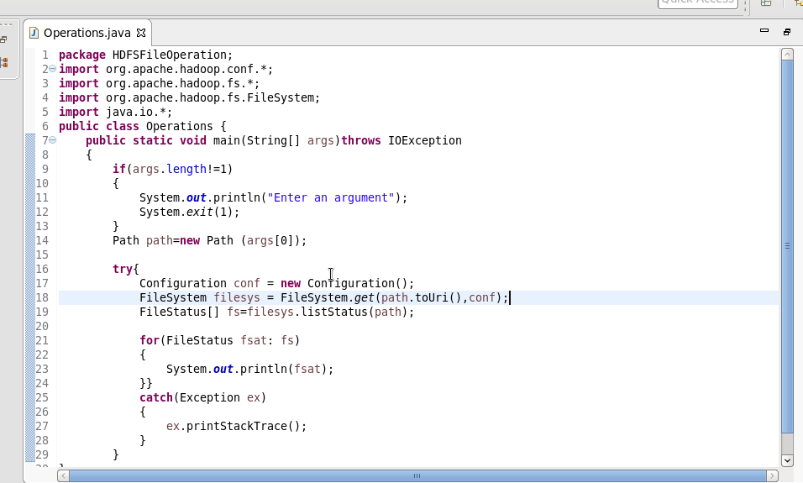

**Output:**

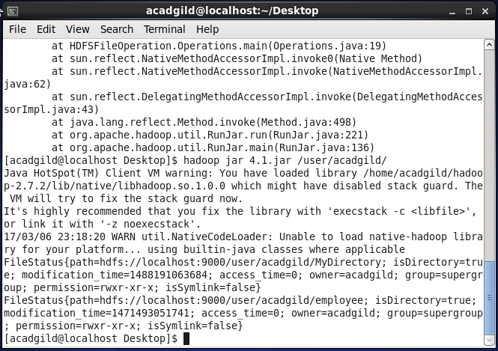

1. **Modify the previous program to list all the files and sub-directories in the HDFS path recursively.**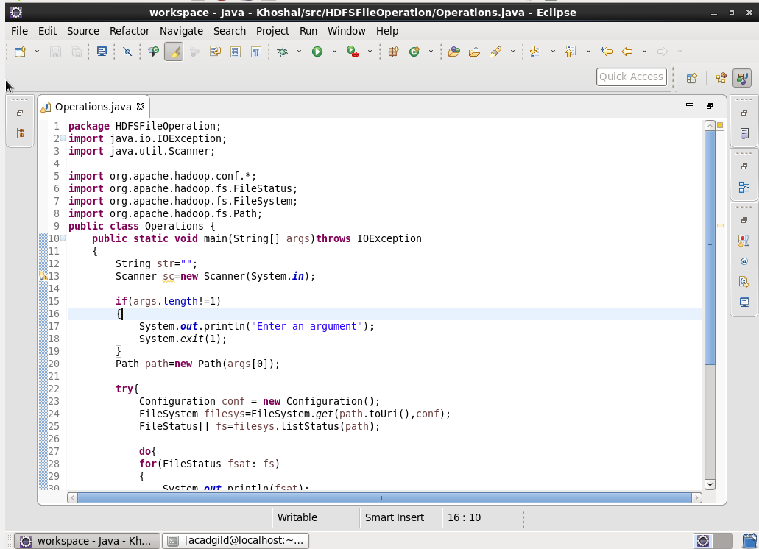

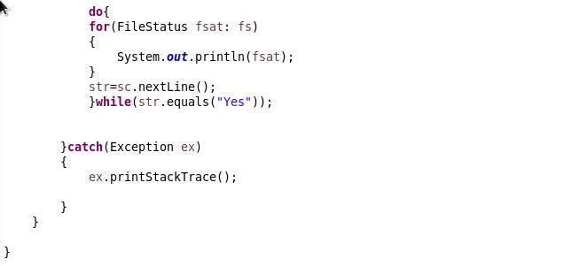

**Output:**

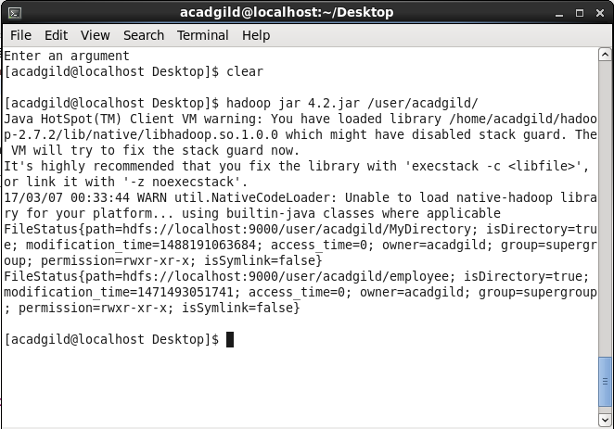

1. **Modify the previous program to take multiple HDFS paths (separated by space) and list all the** **files and sub-directories in those HDFS paths recursively.**

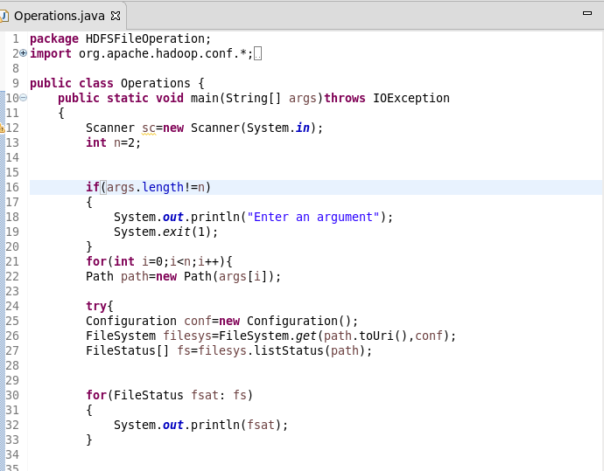

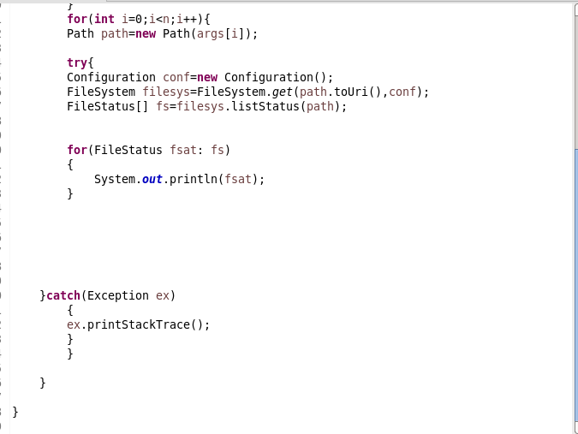

**Output:**

